Network analysis

In this chapter we would like to analyze different features of our network namely: Assortativity, Clustering coefficient, Robustness of the network to the random failure and an attack and finally find the communities in our network with different approaches.

Assortativity:

In general, (dis)assortativity stands for the preference of a network's nodes to attach to others due to their degree. In short, Assortative network is defined as high degree nodes connect with each other avoiding low degree nodes (tend to cliques) and Disassortative network tends to opposite trend, which means that hubs tend to avoid each other.

For the political manifesto network, we expect to find the assortativity in our network regarding the parties with the same manifest tend to connect to each other though the hubs which may stand as the leader of right-left parties should avoid each other, thus not a perfect assortativity behavior but neither disassortative nor neutral network. Fig. 4 shows the assortativity of our network.

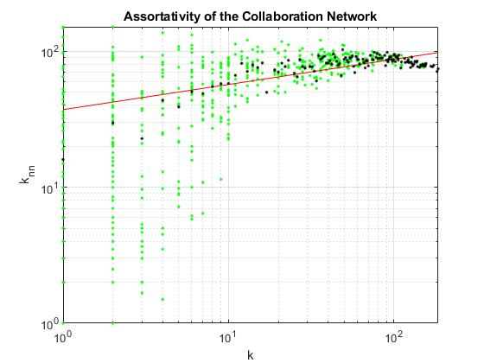

Fig. 4. Assortativity behavior of our network and fitting line for assortativity factor

In this regard, we explore an assortative behavior as we expected and also a structural cut-off for k = 100. Finally the Assortativity factor is 0.18504 for our network.

Clustering Coefficient:

Analyzing the neighbors of each parties lead us to find the clustering coefficient and compute the average clustering coefficient for political manifest network. In short, the clustering coefficient measures the density of links in the neighborhood which means how the parties which are tightened to each other as a neighbor are linked. Moreover, we plot the CCDF of the clustering coefficient to represent the behavior of the network for neighbors. Fig. 5. Show the result:

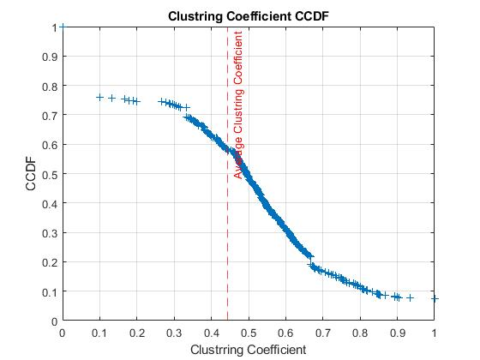

Fig. 5. CCDF of clustering coefficient and average measurement

In this figure we also consider the nodes which have zero coefficient which are almost 20% of our nodes, due to that there parties which are not linked as a tripled graph. In addition, the average clustering coefficient measurement for our network is: 0.446

Robustness:

One of the most important aspect of studying political manifest would be to find the robustness of the network. It leads us to find the property of being strong in a community. Interesting part of this study would be to find when we can failure a network and how to do it. For instance, consider a competition that the right parties want to win the left parties. Utilizing this property each community could determine by enlisting which parties or ideas could lead the other community to collapse. Implementing robustness with attack could be consider as a future study of this network. In our computational aspects we only consider whole network for random failure and an attack by removing random nodes and hubs with the highest degree respectively. Fig. 6 show the robustness of our network and as we could realize from the fig. 6. The distance between random failure and an attack for general network is robust and strong to attacks. Moreover, Molly-Reed criteria which is considered as a threshold for vanishing the giant component (GC) in our network is showed by a red line. It means network lower than that criteria would lose the GC.

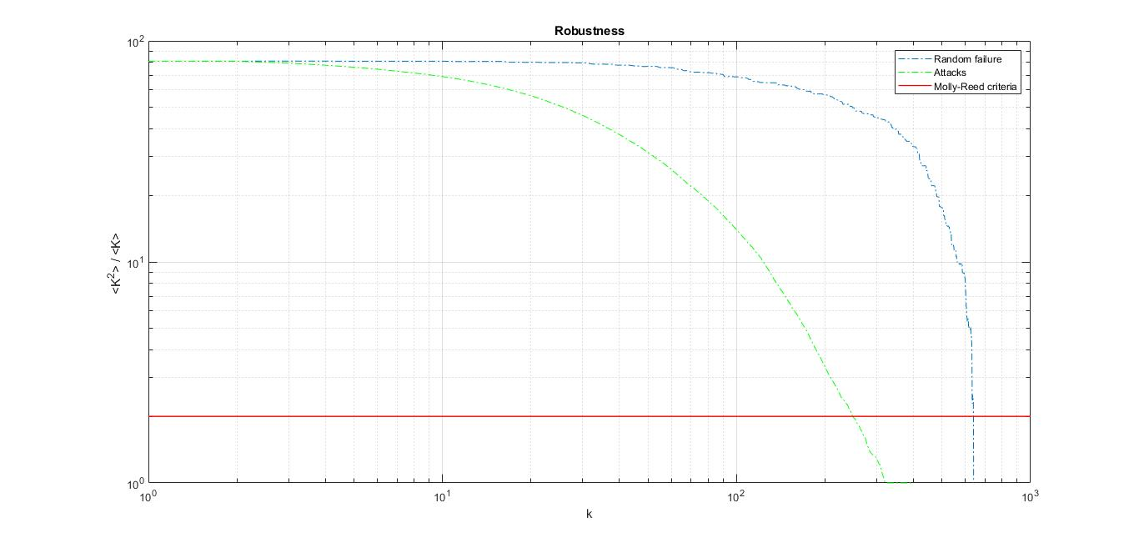

Fig. 6. Robustness of the network for random failure (green) and attack (blue) with Molly-Reed criteria (red)